BCIS 5420, SPRING 2011
MIDTERM EXAM GUIDE AND PRACTICE PROBLEMS

Exam time: Mon., March 7, 6:30 – 8:30 PM

The exam will consist of:
- Two (2) ERD problems – 30 pts each – total 60 pts
- Two (2) ERD-to_logical schema problems (I will use ERDs produced in Oracle, so please review the notations (30 pts each) – total 60 pts
- Four (4) normalization problems at 15 pts each – total 60 pts
- Five (5) multiple choice questions, (4 pts each) – total 20 pts. The M/C questions will cover the following topics:
  - Oracele Designer tools, objects and functionality
  - Translation of ERD to a relational model
  - Properties of a relationship
  - Normalization terminology
  - ERD terminology

Below are some problems and questions that are similar to your exam questions.

Problem 1. Please Draw an ERD for the following problem. (30 pts) State all the necessary assumptions.

As a part of its project management database, the company wants to store information about resources (employees), projects and bookings.

For each employee, the following information is stored: Employee ID, First and Last name, Rank, and billing rate. Employees are organized into solution sets, each solution set has a head of the solution set, who is the resource owner for all employees in that SS. For each solution set we record the SS ID and the SS name. For scheduling purposes, we want to store information about the head of each solution set, and about assignment of employees to solution sets. An employee can belong to only one solution set.

The scheduling system also stores information about project. For each project, the following information is stored: Project ID, Status, Location and Client name.

As a part of the scheduling system, we store information about each calendar day in a year. When a booking is requested for an employee, the employee is scheduled to work on a particular project, on a particular day for the specified amount of time (10%-100%). For each booking we also record current status.

SOLUTION.

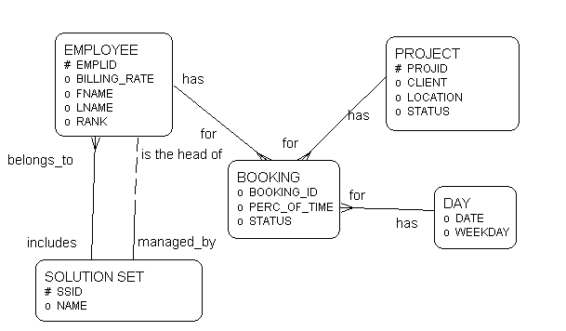

Problem 2. Please Draw an ERD for the following problem. (20 pts) State all the necessary assumptions.

On-line payment system stores information about all customers, including name, id, address, e-mail and password. Each customer has set up a specific method of payment, which may be a credit card payment or automated direct withdrawal. For all types of payment we store the following information: an ID and the date the method of payment was set up. For credit card payments we store CC number and type and the expiration date. For automated withdrawal we store the name of financial institution, the routing number, account number and the date of monthly withdrawal.

SOLUTION. I did some of the work in Oracle, so the attributes are shown inside the entities.

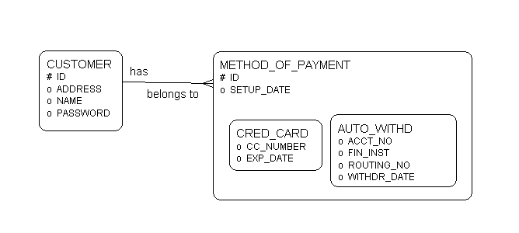

Problem 3. Logical Data Modeling.
Please translate the ERD below into a logical schema. You do not need to specify data types.

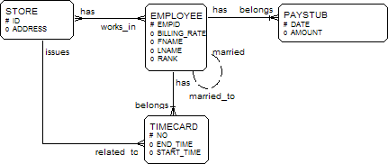

SOLUTION:

STORE (ID, ADDRESS)

STORE_EMPLOYEE (STORE_ID, EMPID)

EMPLOYEE (EMPID, FNAME, LNAME, BILLING_RATE, RANK, SPOUSE_ID)

TIMECARD (EMPID, NO, START_TIME, END_TIME, STORE_ID)

PAYSTUB (EMPID, DATE, AMOUNT)

Foreign key are italicized.

Problem 4. Logical Data Modeling.
Please translate the ERD below into a logical schema. You do not need to specify data types. 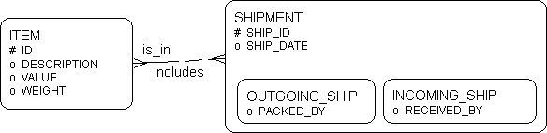

SOLUTION:

ITEM (ID, DESCRIPTION, VALUE, WEIGHT)

ITEM_SHIPMENT (ITEM_ID, SHIP_ID)

SHIPMENT (SHIP_ID, SHIP_DATE)

OUTGOING_SHIP (O_SHIP_ID, PACKED_BY)

OUTGOING_SHIP (I_SHIP_ID, RECEIVED_BY)

Problem 5: Normalization

There will be four (4) such problems in the exam.

Based on the following functional dependencies, determine the Normal Form of the relation INVOICE (explain why) and, if necessary, bring it into a set of 3NF relations.

Dependencies:
Cust# → Name
Cust# → Address
Inv# .→ Cust#,
Inv# .→ Date
Inv# .→ Amount
Inv#, Prod# → Quant
Inv#, Prod# → ShipMethod
Prod# → Descr
Prod# → Price

INVOICE

(Inv #, Cust #, Name, Address, ShipMethod, Date, Quant, Prod #, Descr, Price, Amount).

SOLUTION:

_1_ NF

The Relation is in the 1NF, because there are no multivalued attributes. The Relation has partial dependencies (Cust# → Name, Address; Inv# → Date, Amount; Prod# → Descr), therefore, the relation is non in 2NF. Conclusion, the relation in 1NF.

The relation can be decomposed into the following 3NF Relations:

CUSTOMER (Cust#, Name, Address)

INVOICE (Inv#, Cust#, Date, Amount)

INVOICE_PRODUCT (Inv#, Prod#, Quant, ShipMethod)

PRODUCT(Prod#, Descr, Price)

Normalization problem 2:

Based on the following functional dependencies, determine the Normal Form of the relation SCHEDULE (explain why) and, if necessary, bring it into a set of 3NF relations.

Dependencies:
Section#, CourseID, Semester ID → RoomNo
Section#, CourseID, Semester ID → Inst_ID
Section#, CourseID, Semester ID → Week_day
Section#, CourseID, Semester ID → Start_time
Section#, CourseID, Semester ID → End_time
Course_ID → Course Name
RoomNo → Occupancy
Instr_ID → Instr_name

SCHEDULE

(CourseID, Course Name, Section#, Semester ID, RoomNo, Occupancy, Inst_ID, Instr_Name, Week_day, Start_time, End_time)

SOLUTION:

_unnormalised_ NF

The Relation is unnormalised, because there are multivalued attributes and repeating groups. Specifically, such attributes as Section#, Semester ID, RoomNo, Occupancy, Inst_ID, Instr_Name, Week_day, Start_time, End_time are not determined directly or indirectly by the primary key (CourseID).

The relation can be decomposed into the following 3NF Relations:

SCHEDULE
(Section #, CourseID, Semester ID, RoomNo, Inst_ID, Week_day, Start_time, End_time)

COURSE
(Course_ID, Course Name)

INSTRUCTOR
(Instr_ID, Instr_name)

ROOM
(RoomNo, Occupancy)
Sample MC questions:

Q 1. In a relational model, each entity instance is represented by a

- a table
- a column in a table
- a row in a table - correct
- a foreign key

Q2. A table is in the 1NF if:
- it has no transitive dependencies
- it has no multivalued attributes - correct
- it has no partial dependencies
- all of the above

Q3. Which of the following tools is used for generating DDL based on the Table Definitions
- E-R Modeler
- Repository Object Navigator
- Database Design Transformer
- Design Editor - correct

